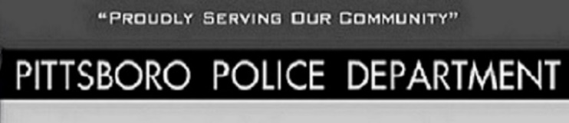
www.in.gov/isp/firearms-licensing/
IF YOU HAVE ANY ISSUES CALL 1-877-472-6917

All NEW license applications incur a $12.95 fee for IDEMIA Electronic Fingerprinting. Additionally, ALL license applications incur an IN.gov processing fee that varies according to the license type.
PITTSBORO POLICE DEPARTMENT DOES NOT DO ANY TYPE OF FINGERPRINTING

Effective July 1, 2022 Indiana will become a Constitutional Carry State
Constitutional Carry is not recognized by all states so you will need to be aware of the gun laws for any state you will be traveling to and have in your possession your license to carry permit
If you do not have a permit, you can still obtain one by visiting https://www.in.gov./isp/firearms-licensing/ The only fee is for fingerprinting which is scheduled from this website
BRING A VALID INDIANA ID AND THE RECEIPT OF FINGERPRINTING TO THE PITTSBORO POLICE DEPARTMENT
MONDAY-FRIDAY 8AM-3:30PM

All businesses have the right to request no firearms be carried into or onto property or that open carry of firearms not be exercised while in or on property. Please be respectful and adhere to the businesses firearms policy.

To check on status of your permit or any other issues with permits or general questions contact: https://www.in.gov./isp/firearms-licensing/

